**RESUME**

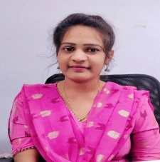N. Rajya Lakshmi

98/c, mothi nagar,

Near brahmmam talent school,

Hyderabad,500018

Mail: rajyalakshmi.n999@gmail.com

Phn: 9676301706

**OBJECTIVE:**

To work in my field of expertise, seeing a quality employment in your esteemed organization where my knowledge can be shared and enriched, looking for the opportunity where I can improve my knowledge.

**EDUCATIONAL DETAILS:**

|  |  |  |  |
| --- | --- | --- | --- |
| **CLASS** | **YEAR** | **INSTITUTION NAME** | **PERCENTAGE** |
| SSC | 2015 | ZPH SCHOOL,VIJAYARAI | 82% |
| INTERMEDIATE | 2017 | KRUSHI VIGNAN JUNIOR COLLEGE,JANAMPET | 80% |
| DEGREE | 2023 | ACHARYA NAGARJUNA UNIVERSITY | 72% |

**WORK EXPERIENCE:**

Working as a tele caller (2years) at Bajaj capital insurance broking limited.

Working as a collection executive (10 months) at Debt care enterprises private limited.

**STRENGTHS:**

Hard working, creative thinking

Good communication skills and ability to work in teams.

**TECHNICAL SKILLS:**

MS OFFICE

**PERSONAL INFORMATION:**

Father’s name : Subbarao

Date of birth : 16/02/2000

Sex : Female

Nationality : Indian

Marital status : Unmarried

Hobbies : Making craft items, listening music

*I hereby declare that all the details provided above are true to the best of my knowledge.*

**( RAJYA LAKSHMI)**